Quick Tip for fixing bottom border line that expands across multiple cells – unintentionally

Click on

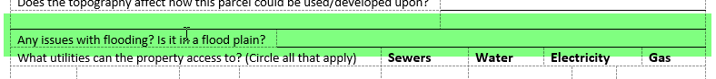

Or

